**SQL QUERIES OF A PIZZA STORE SALES.**

**KPI’S**

1.Showing the whole table of the store sales:

select * from pizza_Sales

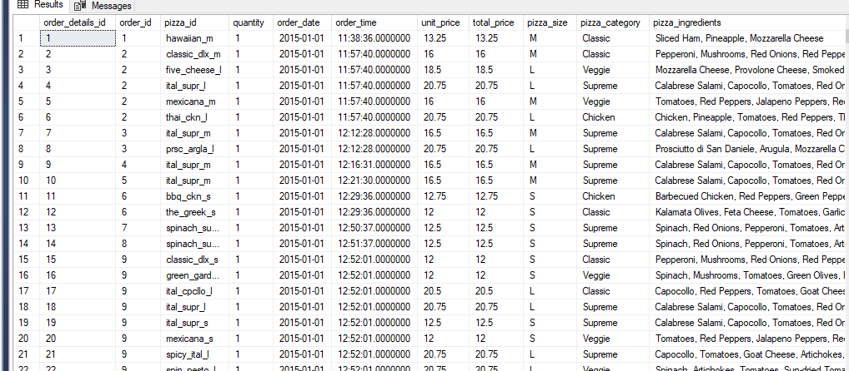

2.Total revenue:

select sum(total_price) As Total_revenue from pizza_Sales

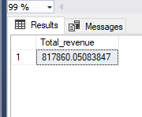

3.AVERAGE ORDER VALUE:

select sum(total_price)/count(distinct order_id) as Avg_order_value from pizza_Sales

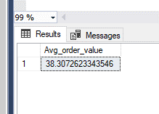

4.TOTAL PIZZAS SOLD:

select sum(quantity)Total_pizza_sold from pizza_Sales

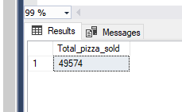

5.Total orders:

select count(distinct order_id) as Total_orders from pizza_Sales

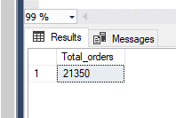

6.Average pizzas sold per order:

select CAST(sum(quantity) as decimal(10,2))/Cast(count(distinct order_id) as decimal(10,2)) as Avg_pizzas_per_order from pizza_Sales

-The cast function brings about the decimal aspect instead of rounding it up to a whole number.

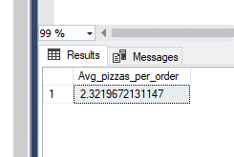

7.Daily trend from total orders:

select datename(dw,order_date) AS order_date,count(distinct order_id) as Total_orders

from pizza_Sales

group by datename(dw,order_date)

-The datetime function convert dates to actual days of the week.

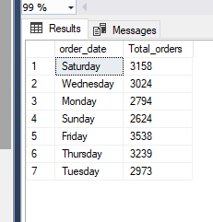

8.Hourly trend per total order:

select datepart(hour,order_time) as order_hours,count(distinct order_id) as Total_orders

from pizza_Sales

group by datepart(hour,order_time)

order by datepart(hour,order_time)

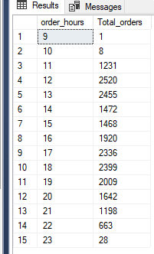

9.Percentage of sales by pizza category:

select pizza_category,sum(total_price)*100/(select sum(total_price) from pizza_Sales)

from pizza_Sales

group by pizza_category

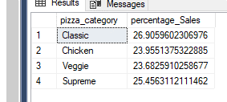

10.Percentage of sales by pizza category per month:

select pizza_category,sum(total_price)*100/(select sum(total_price) from pizza_Sales where month (order_date) = 1) as percentage_Sales

from pizza_Sales

where month (order_date) = 1

group by pizza_category

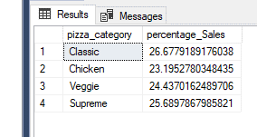

11.Percentage of sales by pizza size:

select pizza_size,sum(total_price) as Total_Sales,sum(total_price) *100 / (select sum(total_price)from pizza_Sales) as percentage_totals

from pizza_Sales

group by pizza_size

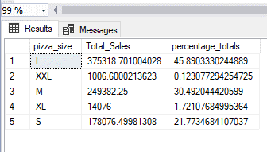

order by percentage_totals desc

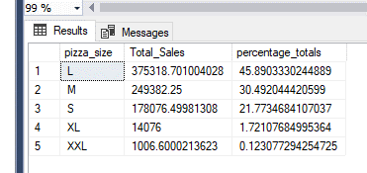

-Percentage of sales by pizza size quarterly:

select pizza_size,sum(total_price) as Total_Sales,sum(total_price) *100 / (select sum(total_price)from pizza_Sales where datepart(quarter,order_date) = 1) as percentage_totals

from pizza_Sales

where datepart(quarter,order_date) = 1

group by pizza_size

order by percentage_totals desc

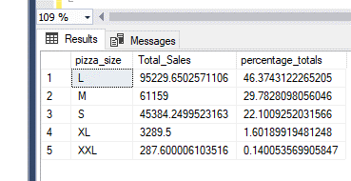

12.Total pizza sold by pizza category:

select pizza_category,sum(quantity) as total_pizza_sold

from pizza_Sales

group by pizza_category

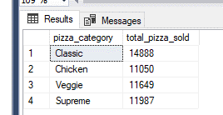

13.top five best sellers by Total pizza sold:

select pizza_name,sum(quantity) as Total_pizza_sold

from pizza_Sales

group by pizza_name

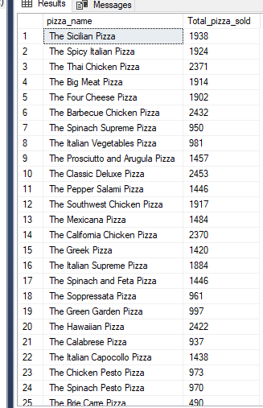

Order by total_pizza_sold:

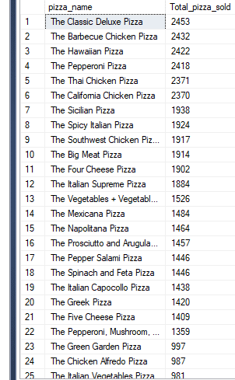

Top 5 best sellers:

select top 5 pizza_name,sum(quantity) as Total_pizza_sold

from pizza_Sales

group by pizza_name

order by Total_pizza_sold desc

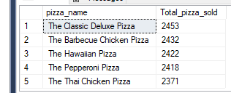

Bottom 5 worsest sellers:

select top 5 pizza_name,sum(quantity) as Total_pizza_sold

from pizza_Sales

group by pizza_name

order by Total_pizza_sold asc

